**MMA 865**

**Big Data Analytics**

**Moez Ali**

**Individual Assignment 1 Instructions**

Version 1: Updated August 10, 2021

# Overview

This assignment contains two (2) questions. The questions are contained in the accompanying Python Jupyter Notebook file named *22W_865.ipynb*. You are to complete the assignment entirely within the Jupyter Notebook file. Once completed, you are to export the Notebook as a PDF file as follows:

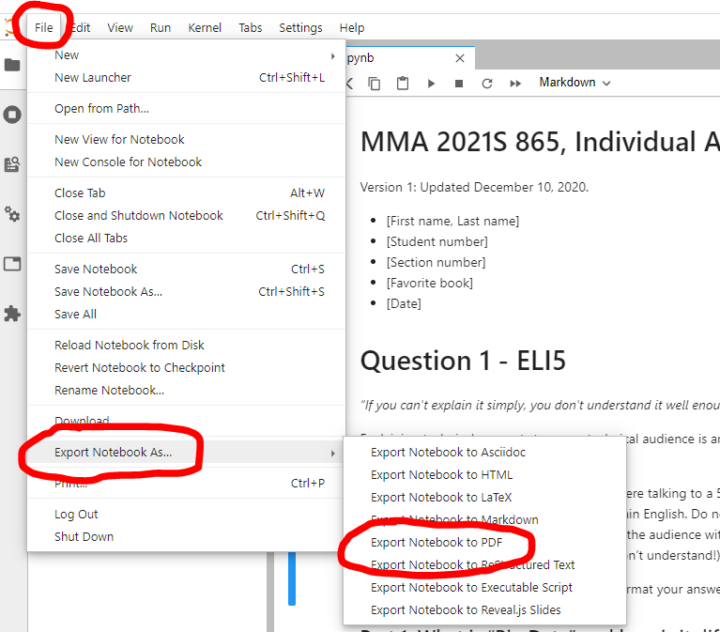

# What to submit

* **Please do not submit the Jupyter Notebook (.ipynb) file to the course portal.**
* **Please submit the PDF export of the Notebook.** 
  + Please name your file 21S_865_FirstnameLastName.pdf
    - E.g., 22W_865_MoezAli.pdf
  + Please make sure you have run all the cells so we can see the output!
  + Best practice: Before exporting to PDF, make sure to restart the Kernel (to clear any local state) and Re-run all the cells:

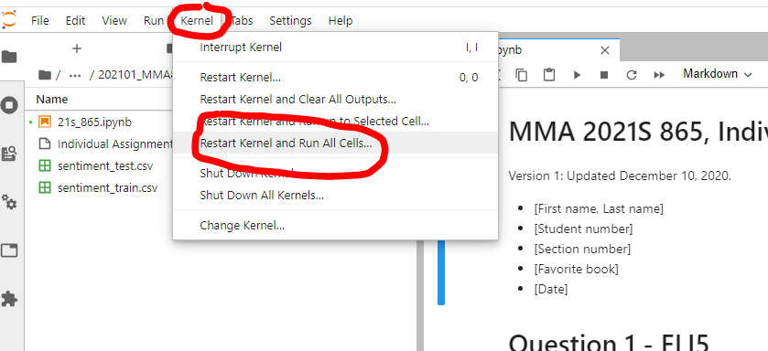

# Question Instructions

Each question has multiple tasks. There are two possible types of tasks: tasks that require you to write code and tasks that require you to write text responses. A grading rubric is provided on D2L for each question.

For tasks that require **code**:

* Use Python to complete the task.
* You may use standard Python libraries, including scikit-learn, pandas, and numpy.
* Tips:
  + Submit code that runs without errors.
  + Submit code that is reproducible. E.g., set random number seeds as appropriate. You should be able to run you code again and again and again, from the top of the file to the bottom of the file, and get the exact same results each time. I should be able to run your code, from scratch, on my machine, again and again, and get the exact same results that you get.
  + Submit code that is organized. Make your code readable. Provide comments to describe what the code is doing and why. Don’t leave “old” code laying around. Overall, if your code is clear and easy to read, then we will be happy. When we are happy, we give better marks.

For tasks that require **text responses**:

* Type your response in Notebook cell indicated.
* Use English. Use proper grammar, spelling, and punctuation. Be professional and clear. Be complete, but not overly-verbose.
* Feel free to use [Markdown syntax](https://www.markdownguide.org/basic-syntax/) to format your answer (i.e., add bold, italics, lists, tables).
* You may refer to your code in your answer. Please do so very clearly. E.g., “As can be seen in on line X above …“